Recall the programming using scratch. Which of the following set of instructions will not end up getting the sprite (the cat) back at the initial  
    state (both in terms of movement and the angle)?

 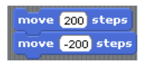

 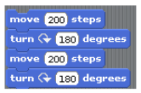

 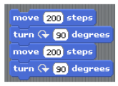

 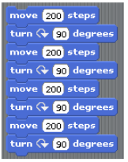

***1 point***

What is the output of the following  
  
 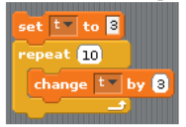

 3

 33

 30

 None of the above

***1 point***

What is the output of the following  
  
 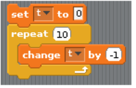

 0

 10

 -10

 None of the above

***1 point***

When we double click the following instructions, the sprite (cat)  
  
 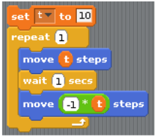

 keeps moving forward

 moves forward in steps of 10

 moves backward 10 steps and then come back to its original position

 moves forward 10 steps and then come back to its original position

***1 point***

Assuming our sprite to be an aeroplane now, the following instructions represent an aeroplane  
  
 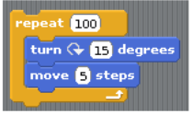

 moving forward

 falling

 moving backward

 making circular motions

***1 point***

Consider 2 blocks of instructions shown below for an aeroplane sprite. Choose the correct option from the following  
  
 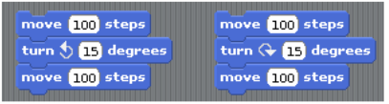

 First block represents landing while the second represents takeoff

 First block represents takeoff while the second represents landing

 Both the blocks represent takeoff

 Both the blocks represent landing

***1 point***

Which of the following represents the code block for a jumping baseball which initially jumps to a height of 200 and then in every subsequent  
    iteration reaches 3/4th of the height in the previous iteration till it comes to rest.

 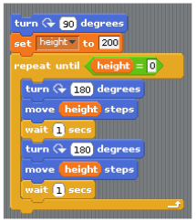

 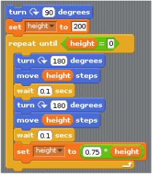

 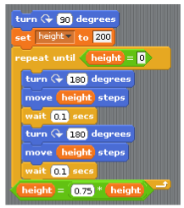

 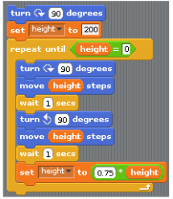

***1 point***

Imagine a ghost sprite. What does the following block of instructions represent  
  
 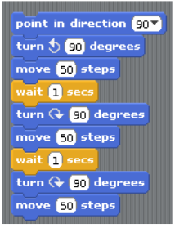

 Ghost going vertically up and then down

 Ghost going backward and then forward

 Ghost going up, flying forward for some steps and then coming down

 None of the above

***1 point***

Which of the following is true?

 We can not implement an infinite loop using scratch

 We can not create a random integer using scratch

 Scratch does not have an explicit square root function

 Scratch does not have an explicit power function

***1 point***

What does the following code compute  
  
 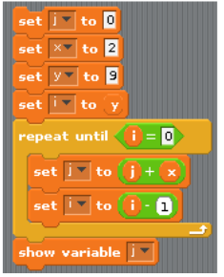

 multiplication of x and y

 x to the power y

 factorial of x

 None of the above